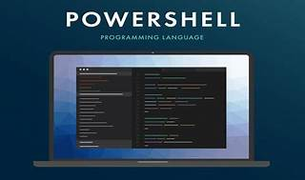

Explore

Certainly! In a nutshell, **PowerShell** is a **cross-platform task automation solution** that runs on Windows, Linux, and macOS. It combines a **command-line shell**, a **scripting language**, and a **configuration management framework**. Here are some free resources to help you learn PowerShell:

1. [**Microsoft Learn**](https://learn.microsoft.com/en-us/powershell/scripting/overview?view=powershell-7.4): Microsoft’s official platform offers interactive learning modules specifically tailored for PowerShell.
2. [**Digital Citizen**](https://www.digitalcitizen.life/simple-questions-what-powershell-what-can-you-do-it/): Learn about PowerShell, its usage, and why it’s essential for managing systems.
3. [**Wikipedia**](https://en.wikipedia.org/wiki/PowerShell): Explore the Wikipedia page for an overview of PowerShell’s history and features.
4. [**Codecademy**](https://www.codecademy.com/learn/learn-powershell): Dive into interactive lessons covering variables, operators, control flow, objects, arrays, and functions.
5. [**The Lonely Administrator**](https://jdhitsolutions.com/blog/essential-powershell-resources/): Discover essential resources for beginners, including books, training videos, and online material.

Happy learning! 🚀🔍📚